
The meeting of Satterthwaite Parish Council to be held in the Parish Room, Satterthwaite on Monday 7th September 2026 at 7.30 pm for the purpose of transacting the business outlined in the agenda below.
Agenda
Item |  | Additional  information
Opening Administration
1 | Welcome and Introductions  Apologies  None
2 | Declarations of interest  - To receive declarations by elected and co-opted members of disclosable pecuniary interests in respect of items on this agenda
3 | Requests for Dispensations  - The clerk to report any requests received since the previous meeting for dispensations to speak and/or vote on any matter where a member has a disclosable pecuniary interest.
4 | Minutes  - Chair to review and sign last meetings minutes on 13^{h} July 2026 | Minutes attached from 13^{h} July 2026
Matters for consideration
5 | Public participation  - To receive comments and representations from members of the public in relation to any item on the agenda  - To dial in residents attending remotely
6 | Updates on ongoing issues and actions from last meeting  Review of action log  - Playground quotes – awaiting 4th company and tennis court renovation  - Village Parking – Planning application rejected -complaint re: overall process sent to LDNPA – no acknowledgement after 2 emails.  - Moor lane and motorcyclists  - Community resilience plan  - Shape future plan response  - Unity banking  - Dale park caravans | Action log
7 | Items for meeting not covered above  - Wall up towards Hill Top houses  - Parking on Church Lane  - Gritting for winter
8 | Additional or urgent points to raise regarding Parish or Councillor matters
9 | Items for the Lengthsman
Planning
10 | Planning Consultations sought from Parish Council  - 7/2026/5391 Installation of 4 wooden installations along the Millwood trail – no consultation needed  - 7/2026/5333 Sewage Treatment plant installation Bank cottage – supported
Finance
11 | Accounts since last meeting  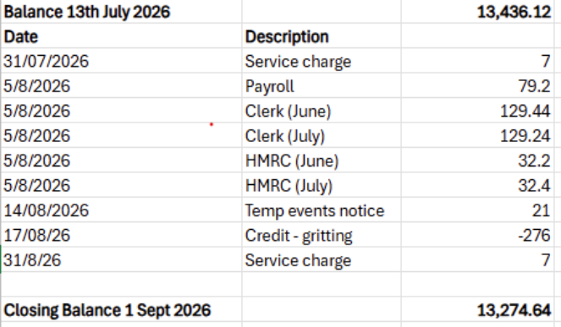
Key correspondence, consultations and reports not covered above
12 | Extra Mile bookable bus service
13 | Tour de France 2027 – event planning
14 | LDNPA Rusland woodland management plan
15 | Community Governance review final recommendations
16 | Community Safety Partnership Plan for 2027-30 – survey ends 18th September
17 | Potential creation of bridleway through LDNPA woodlands – Colton & Satterthwaite - response by ‘middle of September’
18 | Kendal Urgent Treatment Centre engagement
19 | Joy Maker recruitment
20 | National salary scales for Clerks
21 | National Public Confidence in Policing Survey
Council calendar
22 | Village BBQ 5th September in the playground
Closing administration
23 | Agenda items for next meeting
24 | Next meeting date to be agreed  October 19th 7:30pm Satterthwaite Parish Room

